Profile
Personal Information:
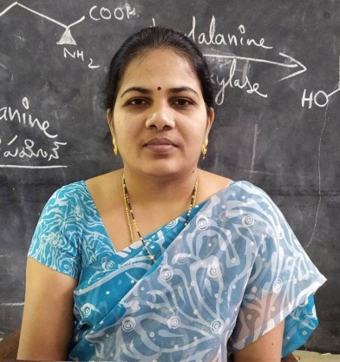
Smt. S.L.Prasanna Dakineni
Lecturer
Department of Chemistry
Dr. V.S. Krishna Govt. Degree College (A)
Visakhapatnam - 530013
A.P., INDIA

https://www.drvskrishnagdc.edu.in
Mobile No: (+91) 8332887645
E-mail ID: slprasanna.dakineni@gmail.com

Education:

- M.Sc Chemistry from IIT Madras 2010
- UGC NET DEC-2009

Orientation/Refresher Programmes:

- Attended 21 days “Refresher Course” at UGC - Academic Staff College, AU Visakhapatnam, A.P. from 30-05-2013 to 19-06-2013.
- Attended 28 days “Orientation Course” at UGC – Human Resource Development Centre, Andhra University, Visakhapatnam, A.P. from 25-05-2018 to 21-06-2018.
- Attended a 5 Day FDP in Chemistry on “New Knowledge, Advanced Teaching & Research: New Frontiers and emerging Technologies” Organized by APCCE, Vijayawada, from 01-07-2020 to 05-07-2020 Online.

SWAYAM-ARPIT :
1. Completed SWAYAM ARPIT Online Course on “Online Refresher course in Chemistry for Higher Education Faculty with “A” Grade offered by Sri Guru Tegh Bahadur Khalsa College, Delhi from 1-11-2018 to 28-2-2019.
2. Completed SWAYAM ARPIT Online Course on “Online Refresher course in Chemistry for Higher Education Faculty with “A” Grade from 01-12-2020 to 31-03-2021 offered by Sri Guru Tegh Bahadur Khalsa College, University of Delhi

Awards/ Fellowships:
- Summer Research Fellowship Programme (SRFP) - 2009: Selected IASc-INSA-NASI Summer Research Fellowship Programme under Student category through the IASc, Bangalore, and worked at IISc Bengaluru, Karnataka under the supervision of Dr. T.N.Guru Row, SSCU, IISc for Two months May-June 2009.
Research Publications:
- Structural and impedance analysis of PAN-based Na⁺ ion conducting gel polymer electrolytes for energy storage device application N. Krishna Jyothi, M. Gnana Kiran V. Naveen Kumar, B. Nageswara Rao, S.L.Prasanna D., K. Vijaya Kumar and M.C. Rao Materials Today: Proceedings 51 (1), 1164-1167 (2022).
- Gold nanoparticles synthesized from Pergulariadaemia leaves extract for Antibacterial, anticancer and UV protection S.L. Prasanna Dakineni, Nageswararao Budiredla, Deepti Kolli and Ramesh Raju Rudraraju Materials Today: Proceedings 51 (1), 928-934 (2022).

Teaching Experience: 10 Years

S. No. | College/ Institute | Duration
1 | RGUKT (IIIT), Nuzvid, Krishna Dist., A.P. | 01.07.2010 | 25.12.2011
2 | Govt. College for Women Srikakulam, A.P. | 26.12.2011 |  | 03.09.2015
3 | Govt. Degree College V.Madugula, A.P. | 04.09.2015 |  | 23.09.2021
4 | Dr. V.S. Krishna Govt. Degree College (A), Visakhapatnam, A.P. | 24.09.2021. |  | Till Date

Membership/ BOS/Research
- BOS Member, Department of Chemistry, Andhra University.

Additional Responsibilities:

- Organising committee member, SAT 2013-14, two day state level workshop on “Capacity building Research Culture in Undergraduate Institutions” on 18-01-2014 to 19-01-2014 sponsored by DRC Srikakulam, at Govt. College for Women Srikakulam.

